Day 2 – HTML/CSS Basics

**HTML Digital Postcard**

Go through the exercise with the students and explain how each step works

let students play around and ask questions

**HTML Exercise**

1. Create a new HTML file in VS Code titled MyWebpage
2. Add the following HTML

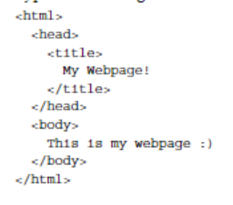

1. Save the code somewhere you can find it later.
2. Go to the file you just created and open it in the browser.
3. Go back to your code and make a new .css file name is MyWebpage as well.
4. Link the css file to the HTML file.



1. Add code to the css file to change the color of the text (Either use * or you can show the students how to add tags and ids in the HTML)
2. Add code to the css file to change the background color.

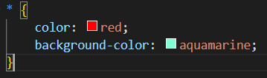

Or

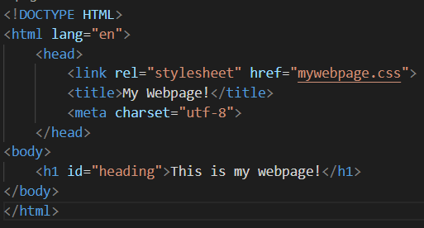

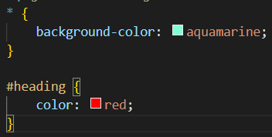

1. Add an image to the HTML file. (You can add whatever you want, just google an image and save it. This is a good lesson for paths as well.)



1. Set the height and width of the image.



1. If you want to go over more css or html you can.

**HTML and CSS Shell**

1. Add Name
2. Add an image of the student
3. Add at least two goals the student has. It could be any goals, not just for the camp.
4. Add at least 2 hobbies
5. Add at least 2 favorite websites.
6. Add student’s email, and their name in the footer.

**Break**

**HTML and CSS Shell Cont… (play around with the css and html if they have finished the main portion)**

**Deploy their pages on GitHub and visit each other’s pages.**